Thank you for choosing Therapydia Portland. In order to best serve you and your individual needs please fill out the information below to the best of your ability. You and your physical therapist will review this form together. If there is anything you do not feel comfortable answering please leave it blank.

Name: _____________________________________________________________________________ Date of birth: ______/______/_____________
Address: __________________________________________________________ City: ________________________ State:______ Zip: ____________
Phone ____________________________________________Email:______________________________________________________________________
Employer: ____________________________________________________________ Work phone:_________________________________________
Emergency contact:_____________________________________________________ Relation:__________________________________________
Contact number:__________________________________________________

How did you hear about us: _________________________________________________________________________________________________
Referring Physician: ________________________________________________________________________________________________________
Primary Care Physician: _____________________________________________________________________________________________________
Have you received treatment for your current condition? Yes/ No. If yes please provide information below:
________________________________________________________________________________________________________________________________

Did your injury occur as a result of an accident: YES / NO. Date of Injury: _____________________________________________
Health Insurance: ___________________________________________________ ID#___________________________________________________

Medical History:
Please list any prescription, over-the-counter medications, or supplements you are taking:
_______________________________________________________________________________________________________________________________
________________________________________________________________________________________________________________________________
Please list any surgeries or conditions you have been hospitalized for: _______________________________________________
_______________________________________________________________________________________________________________________________
Please provide a brief history of your condition:____________________________________________________________________
________________________________________________________________________________________________________________________________
________________________________________________________________________________________________________________________________
Have you had prior episodes? Yes / No. If yes please provide a past history__________________________________________
________________________________________________________________________________________________________________________________

Please list any recent imaging:
X-ray Date:_______________ MRI Date:__________ CT Scan Date:__________ Other:_______________________
Please circle all of the following conditions that apply to you both presently or in the past:
High blood pressure Epilepsy/seizure Gout Varicose Veins
Chest Pain/Heart attach Kidney Disease Hepatitis Dizziness/Vertigo
Stroke Asthma Arthritis Depression
Heart Disease Hearing Loss Tuberculosis Lung Disease
Diabetes Cancer Osteoporosis Recent Illness
Emotional/Psychological:________________________________ Chemical Dependency:________________________________
Alergies:______________________________________________________________________________________________________________
Other:_________________________________________________________________________________________________________________
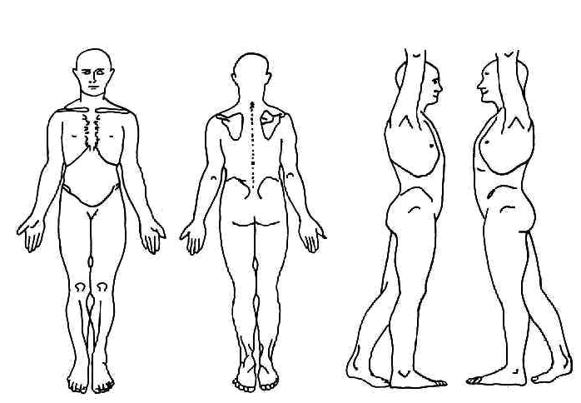
Please use the body chart below to indicate the quality and location of your symptoms. Examples of symptom quality: sharp, shooting, burning, achy, dull, constant, intermittent

Rate your pain on a scale from 0-10 over the last 24 hours.

0 ______ 5 ___ ______ 10
(No pain) (Severe pain)

_____________________________________________________________________________________________________________
Patient signature (if minor, parent or legal guardian must sign) Date
I attest that the above information is true and accurate to the best of my ability. I understand and do hereby agree and give my consent for Therapydia Portland to provide medical care and treatment to me (or my child) considered necessary and proper in diagnosing or treating my (or his/her) condition.

Office Policies

Consent for Treatment: I hereby agree and give my consent for Therapydia Portland to provide physical therapy care and treatment considered necessary and proper in evaluating or treating my physical condition. This consent is intended as a waiver of liability for such treatment excepting acts of negligence. ______(initial)

Parental Consent for Treatment: As parent and/or legal guardian of _______________________________, I authorize Therapydia Portland to treat while I am not present.
Parent/Guardian Signature: ________________________________________ Date: ______________

Cancellations and No-Shows: Appointments cancelled with less than 24-hours notice and no shows will be subject to a fee of $75 to be paid at next appointment or billed to you _____________(initial)

Payment Policy:
Payment due at time of service
Therapydia Portland is in-network with Regence BCBS Oregon, Cigna, Humana, SAIF, United Health Care, Tricare and Medicare.

Assignment of Benefits: I understand and authorize the release of medical information to file health insurance claims for me by Therapydia Portland. I also authorize my insurance provider(s) to pay Therapydia Portland directly. ______(initial)

In-Network Insurance Benefits: It is your responsibility to know your benefit information and you are ultimately financially responsible for all services rendered to you. As a courtesy, we will call to verify benefits prior to your first appointment, if you have provided your insurance information to our office we will summarize this information for you. If the information provided by your insurance company is inaccurate or the insurance company changes its coverage, you will be financially responsible for payment for services and any charges not covered by your insurance plan. You further understand that this agreement is binding regardless of any legal transaction currently in progress or initiated during or after the course of your treatments unless agreed to in writing by yourself and a representative of Therapydia Portland. Actual patient responsibility can only be determined once your insurance company has processed a claim. If you have further financial obligation than what we collected in the office, you will receive a statement from our billing company to be paid in full within 30 days. If your account is deferred to a collection agency, you agree to pay all collection costs incurred. _____ (initial)

Out-of-Network Insurance Benefits: If we are out-of-network with your insurance provider, you are responsible for payment of your out of network co-pay, co-insurance or deductible at the time of service. We will assist you in submitting a superbill to your insurance and you will receive reimbursement directly from them or from Therapydia, if payment is made directly to the clinic. For clients without insurance or who do not wish to submit a superbill, Therapydia Portland offers a cash rate.

I have read and understand the above information and I understand my responsibility for the payment of my account.

Patient Signature: _________________________________________ Date: ________________________

